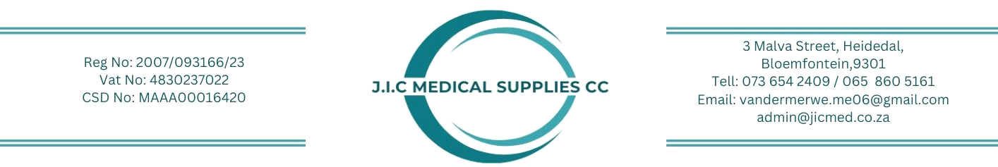
QUOTATION REQUEST:
DATE 19 October 2026
ATT: SALES
TO: Clinic Supplies
West Street
Houghton Estate
Johannesburg
EMAIL: hello@clinicsupplies.co.za
Kindly forward us an urgent quotation on the following item(s).
CODE | DESCRIPTION | QTY | PRICE
Pulse oximeter device requirements  - Handheld pulse oximeter  - Portable handheld design  - High-resolution colour LCD display  - Plethysmography waveform display rechargeable lithium-ion battery and charger included  - Backup batter capacity  - Pulse strength/perfusion display  - Measurement performance SpO₂  Measurement range :0-100  Pulse rate  Measurement range :18-300  Operating modes  Spot-check monitoring mode  Continuous monitoring mode  - Memory  - trend storage capacity  - patient data storage  Alarms  - Audible alarms  - Visual alarms  - Adjustable alarms limits  Probes/sensors  - Adult reusable SpO₂  - Pediatric reusable SpO₂  - Neonatal reusable SpO₂  Accessories  - Rechargeable battery  - Charger/docking station  - Protective carry case  - User manual  - Power adaptor  Connectivity  - Data transfer capability  - Patient data download and storage  Recommended configuration  - Adult sensor  - Paediator sensor  - Charger  - Carry case  - Training  - Warranty |  | 14

Thank you for your support in this matter.

Regards,

Magriet
Sales & Orders

