Sl No | Item Description | Size | UOM | Quantity | Picture of Required Items
1 | Hand gloves, Miller Performance TIG Welding Leather Gloves, SKU : 263346, EN 388, Short length | 9 | Pair | 1 | 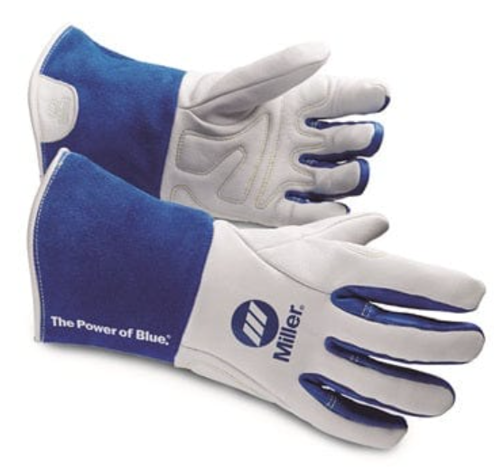
2 | Hand gloves, Asbestos cloth, Heat resistant upto 350 Degree | 7 | Pair | 2 | 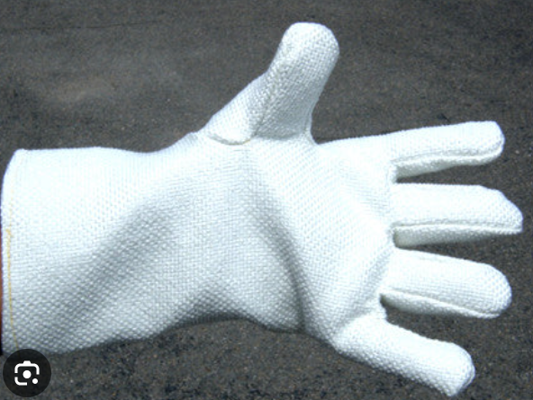
2 | Hand gloves, Asbestos cloth, Heat resistant upto 350 Degree | 8 | Pair
2 | Hand gloves, Asbestos cloth, Heat resistant upto 350 Degree | 9 | Pair | 7
3 | Safety Goggles, Industrial standard, Como KN rated safety goggles | Standard | Piece | 51 | 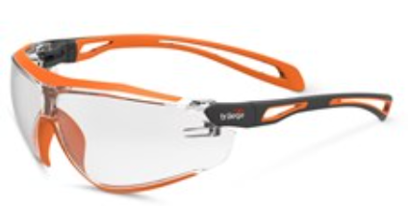
4 | 3M Brand Disposable Protective Coverall 4540+ (Type 5/6), Liquid Chemical Splash & Particulate Protection, | S | Piece | 144 | 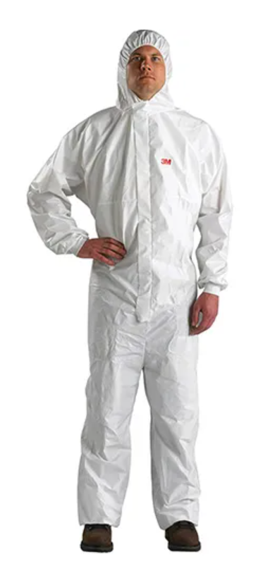
4 |  | M | Piece | 962
4 |  | L | Piece | 336
4 |  | XL | Piece | 384
4 |  | 2XL | Piece | 24

Please note: The item No 4 (3M Brand Disposable Protective Coverall) must be schedule stagger deliver every 3month once ¼ quantities.
SL No | Item Description | Size | UOM | 1st Batch Delivery | 2nd Batch Delivery | 3rd Batch Delivery | 4th Batch Delivery
 |  |  |  | QTY | QTY | QTY | QTY
a | Disposable Protective Coverall 4540+ (Type 5/6), Liquid Chemical Splash & Particulate Protection, | S | Piece | 36 | 36 | 36 | 36
b |  | M | Piece | 241 | 241 | 240 | 240
c |  | L | Piece | 84 | 84 | 84 | 84
d |  | XL | Piece | 96 | 96 | 96 | 96
e |  | 2XL | Piece | 6 | 6 | 6 | 6

